What will we be learning?  Magnetism - TRIPLE | Why this? Why now?  Waves  Electricity 1 & 2  AQA Physics | Key Words:  Make sure you know the definitions of these keywords and use them in your answers.  Pole  Attract / repel  Induce  Magnetic flux density  Solenoid  Electromagnet  Motor Effect  Electromagnetic induction  Transformer  Flemming’s Left Hand Rule  Relay  Generator Effect  Alternator  Dynamo
What will we learn?
F = BIl Force = magnetic flux density x current x length
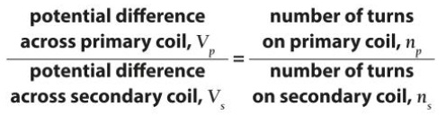
(Equations are given on the formulae sheet)
Common Misconceptions: All metals are magnetic
What opportunities are there for wider study?
Mechanical Engineer Sound engineer Electronic Engineer
Electrical engineer
Energy Provider Specialist Environmental Design

How will I be assessed?
Deep Marking Task Title for this unit: Moving coil sound devices
Required Practical(s) for this unit: None

